**How to Order Your Balance Sheets:**

Motivation:

Almost every bank offers a download of your balance sheets as a comma separated value list like the one shown below: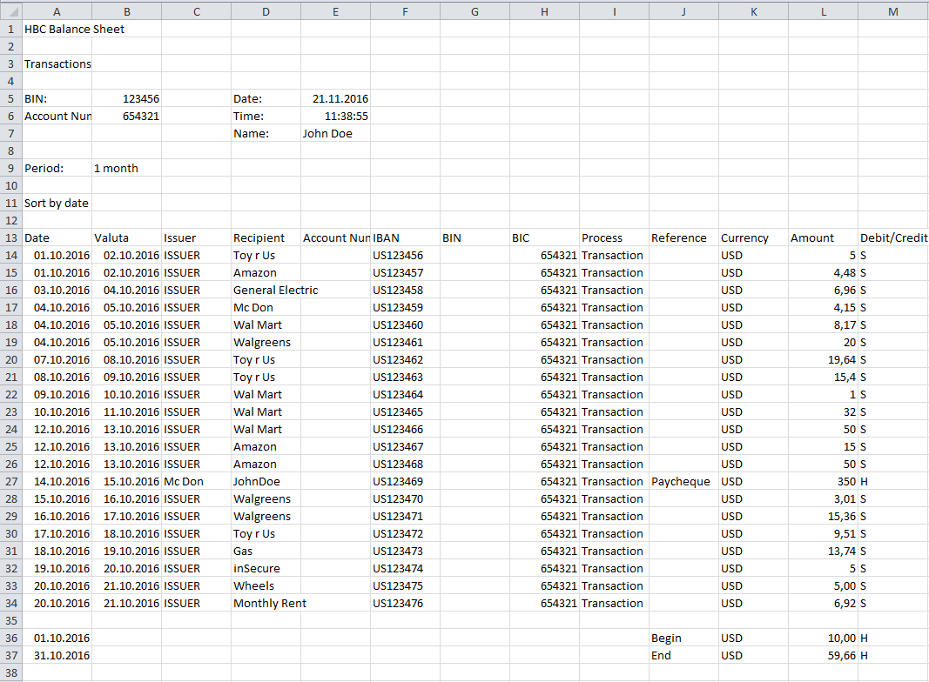

It is annoying to sort this list and add every value to a specific type. For instance I would like to have a list, where I can see how much I spent for housing and shopping last month.

In the list above I would have to copy every line containing Toy r Us, Amazon, Mc Don, Wal Mart and Walgreens and paste it into another sheet, to calculate the amount I have spent for shopping last month.

I would have to do this every month and for every type I want to have an eye on.

Solution:

The Balance Sheet Creator is doing this for you.

*Step 1:*

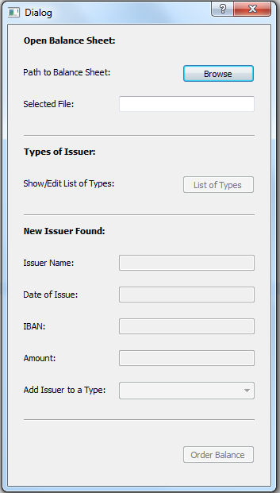

Start the Balance Sheet Creator and select the Balance Sheet you want to order by clicking ‘Browse’

*Step 2:*

After clicking ‘Browse’ the Button ‘List of Types’ will be enabled. Click it.

If you use it for the first time a list of types will be generated automatically as a comma separated value list.

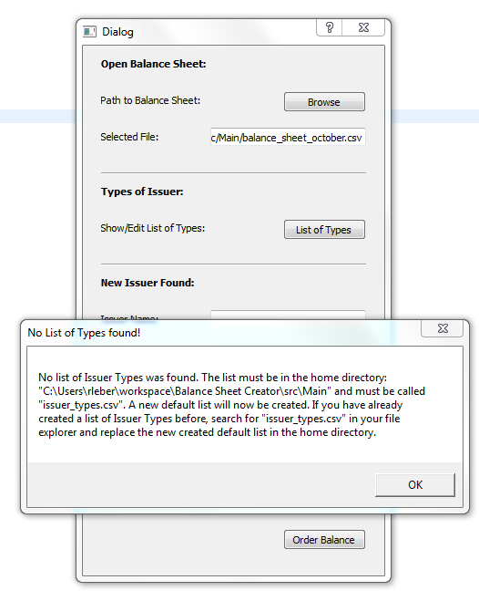

Click ‘OK’ and once again click ‘List of Types’ to see the list that has been created for you.

This is your list of types.

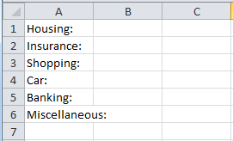

You can modify the list and add new types that make sense to you or delete some. Like I did below:

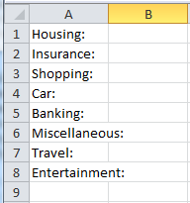

I added the types Travel and Entertainment.

*Step 3:*

Click ‘Order Balance’ to start the procedure. The script is searching if the first value of your balance sheet has already been mapped to a type. Because you are doing it for the first time and you have just created your types list, nothing is mapped so far.

The first value in the example balance sheet is the 5USD bill from Toy r Us from the 01.10.16.

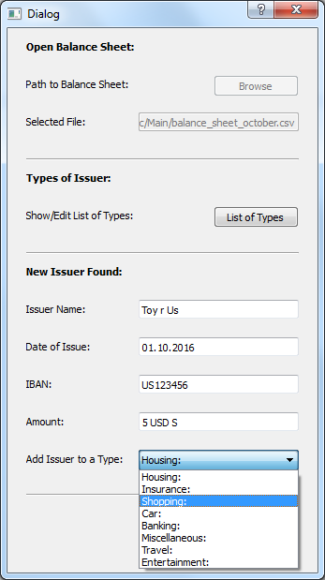

Click the dropdown menu to add this value to a type in your types list. In the example above I mapped it to shopping.

*Step 4:*

Let us have a look at the types list to see what happened. So click ‘List of Types’.

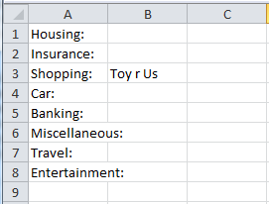

As you see, Toy r Us are mapped to shopping in the types list. The next time the script will know that Toy r Us is a value of the type shopping and will not ask you again.

Close the list of types. Otherwise the program cannot map other types to the list.

Continue mapping. The next Item in the list is the Amazon bill from the 01.10.16. I mapped it to shopping as well.

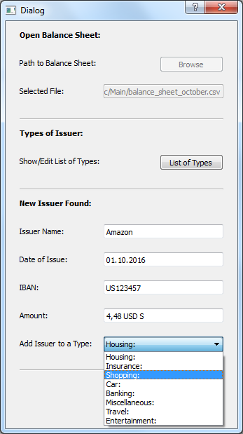

After every value has been mapped, your ordered balance sheet will show up:

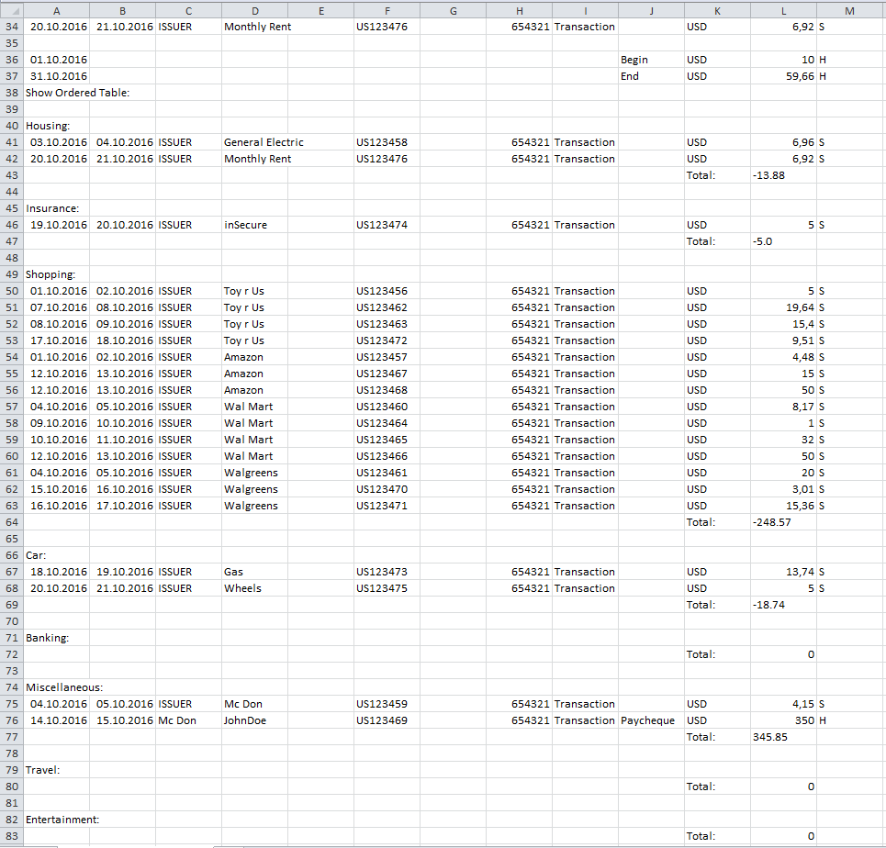

You see what you spent for each type last month.

Let us have a look at the list of types now after everything has been mapped:

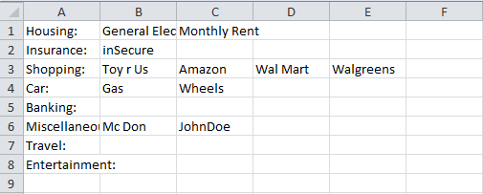

You can modify your list of types any times.

*Step 5:*

You can now go on and order your balance sheet of the next month, or from the last year, or from any time you want.

*Hints:*

-The script was tested with the python2.6 interpreter

-Make sure that there are no empty lines or spaces at the end of your csv(comma separated values) lists(balance sheet and list of types). Otherwise you get an Index out of range exception

-Always close your csv-lists when you are ordering. Otherwise the script cannot write into the files

-A list can only be ordered one time

- If you have a balance sheet in another format, like the first value starts at line 20 and the amount is placed in column 7, then you have to change the following variables in the startOrder(e) thread:

habenSollIndex = 12 #Column of debit or credit sign in balance sheet

amountIndex = 11 #Column of amount in balance sheet

startList = 14 #Line to start searching for values in balance sheet

debit = *'S'* #Character to search for if its debit

credit = *'H'* #Character to search for if its credit

-Have fun by improving this template!